**PRACTICAL NO. 2**

**AIM: Subquery-join operations on Relational Schema**

**USING (practical 1)**

**1. Count the customers with grades above Bangalore’s average.**

**Code:**

SELECT COUNT(*)

FROM Customer

WHERE grade > (

SELECT AVG(grade)

FROM Customer

WHERE city = 'Bangalores'

);

**Output:**

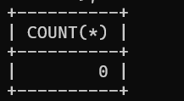

**2. Find the name and numbers of all salesmen who had more than one customer.**

**Code:**

SELECT S.name, S.salesman_id

FROM Salesman S

JOIN Customer C ON S.salesman_id = C.salesman_id

GROUP BY S.salesman_id, S.name

HAVING COUNT(C.customer_id) > 1;

**Output:**



**3. List all salesmen and indicate those who have and don’t have customers in their cities**

(Use UNION operation.)

**Code:**

SELECT S.salesman_id, S.name, 'Has Customers' AS customer_status

FROM Salesman S

JOIN Customer C ON S.salesman_id = C.salesman_id

WHERE S.city = C.city

UNION

SELECT S.salesman_id, S.name, 'No Customers' AS customer_status

FROM Salesman S

LEFT JOIN Customer C ON S.salesman_id = C.salesman_id AND S.city = C.city

WHERE C.customer_id IS NULL;

**Output:**

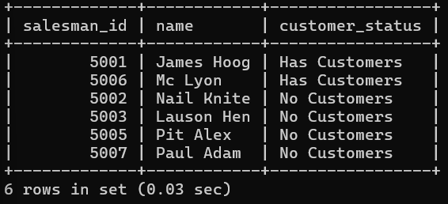

**4. Create a view that finds the salesman who has the customer with the highest order of a day.**

**Code:**

CREATE VIEW SalesmanWithHighestOrder AS

SELECT S.salesman_id, S.name, O.order_date, MAX(O.purch_amt) AS max_order_amount

FROM Salesman S

JOIN Customer C ON S.salesman_id = C.salesman_id

JOIN `orders` O ON C.customer_id = O.customer_id

GROUP BY S.salesman_id, S.name, O.order_date;

select * from SalesmanWithHighestOrder;

**Output**

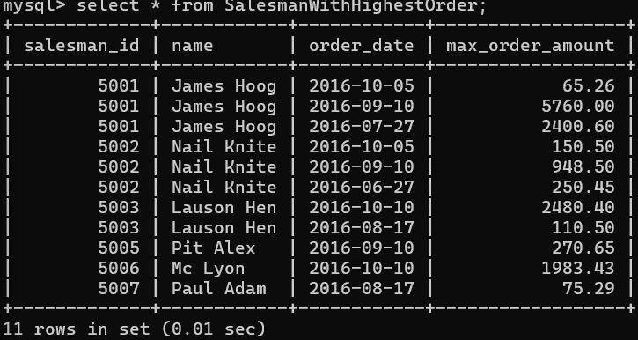

**5. Demonstrate the DELETE operation by removing salesman with id 1000. All his orders must also be deleted**

**Code:**

DELETE FROM salesman WHERE salesman_id = 1000;

SELECT * FROM Salesman;

SELECT * FROM Orders;

**Output:**

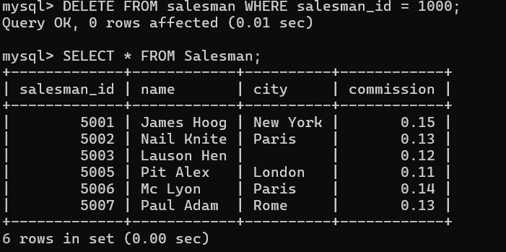

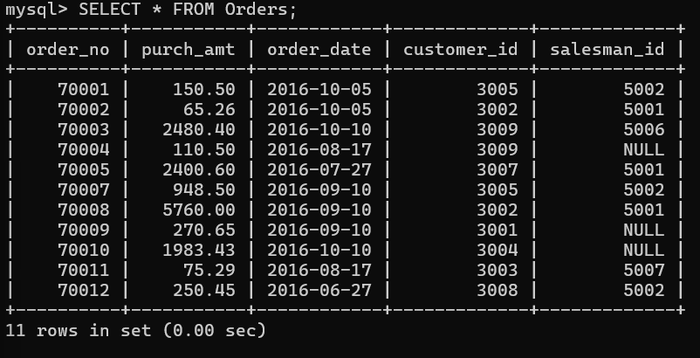

**2. Design ERD for the following schema and execute the following Queries on it:**

**Consider the schema for Movie Database:**

**ACTOR (Act_id, Act_Name, Act_Gender)**

**DIRECTOR (Dir_id, Dir_Name, Dir_Phone)**

**MOVIES (Mov_id, Mov_Title, Mov_Year, Mov_Lang, Dir_id)**

**MOVIE_CAST (Act_id, Mov_id, Role)**

**RATING (Mov_id, Rev_Stars)**

**Code:**

CREATE TABLE ACTOR (

ACT_ID INT (3),

ACT_NAME VARCHAR (20),

ACT_GENDER CHAR (1),

PRIMARY KEY (ACT_ID));

**Output**

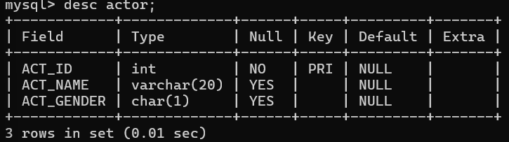

**Code:**

CREATE TABLE DIRECTOR (

DIR_ID INT (3),

DIR_NAME VARCHAR (20),

DIR_PHONE INT (10),

PRIMARY KEY (DIR_ID));

**Output:**

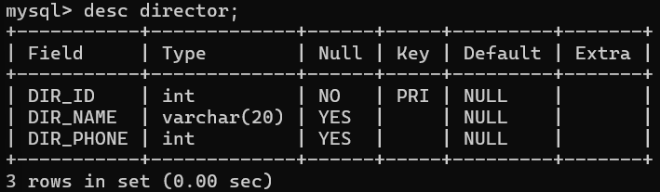

**Code:**

CREATE TABLE MOVIES ( MOV_ID INT (4),

MOV_TITLE VARCHAR (25),

MOV_YEAR INT (4),

MOV_LANG VARCHAR (12),

DIR_ID INT (3),

PRIMARY KEY (MOV_ID),

FOREIGN KEY (DIR_ID) REFERENCES DIRECTOR (DIR_ID));

**Output:**

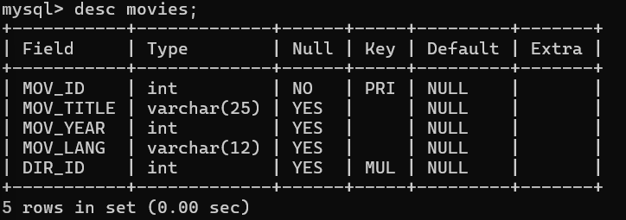

**Code:**

CREATE TABLE MOVIE_CAST ( ACT_ID INT (3),

MOV_ID INT (4),

OLE VARCHAR (10),

PRIMARY KEY (ACT_ID, MOV_ID),

FOREIGN KEY (ACT_ID) REFERENCES ACTOR (ACT_ID),

FOREIGN KEY (MOV_ID) REFERENCES MOVIES (MOV_ID));

**Output:**

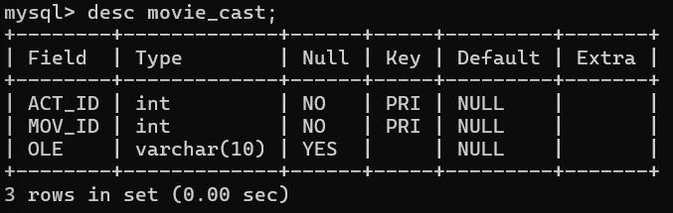

**Code:**

CREATE TABLE RATING ( MOV_ID INT (4),

REV_STARS VARCHAR (25),

PRIMARY KEY (MOV_ID),

FOREIGN KEY (MOV_ID) REFERENCES MOVIES (MOV_ID));

**Output:**

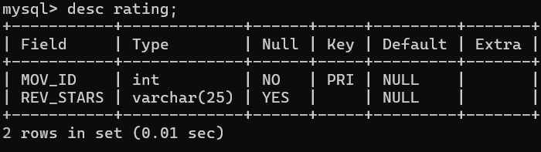

**Values of ACTOR**

**Code:**

INSERT INTO ACTOR VALUES (301,'ANUSHKA','F');

INSERT INTO ACTOR VALUES (302,'PRABHAS','M');

INSERT INTO ACTOR VALUES (303,'PUNITH','M');

INSERT INTO ACTOR VALUES (304,'JERMY','M');

**Output:**

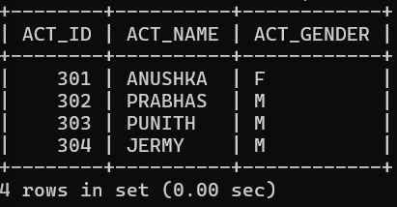

**Values of DIRECTOR**

**Code:**

INSERT INTO DIRECTOR VALUES (60,'RAJAMOULI', 875161100);

INSERT INTO DIRECTOR VALUES (61,'HITCHCOCK', 776613891);

INSERT INTO DIRECTOR VALUES (62,'FARAN', 998677653);

INSERT INTO DIRECTOR VALUES (63,'STEVEN SPIELBERG', 898977653);

**Output:**

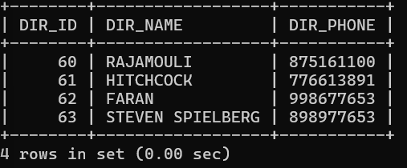

**Values of MOVIES**

**Code:**

INSERT INTO MOVIES VALUES (1001,'BAHUBALI-2', 2017, 'TELAGU', 60);

INSERT INTO MOVIES VALUES (1002,'BAHUBALI-1', 2015, 'TELAGU', 60);

INSERT INTO MOVIES VALUES (1003,'AKASH', 2008, 'KANNADA', 61);

INSERT INTO MOVIES VALUES (1004,'WAR HORSE', 2011, 'ENGLISH', 63);

**Output:**

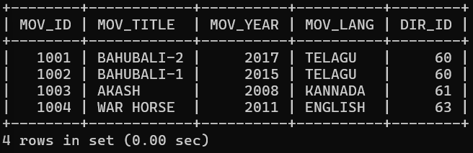

**Values of MOVIE_CAST**

**Code:**

INSERT INTO MOVIE_CAST VALUES (301, 1002, 'HEROINE');

INSERT INTO MOVIE_CAST VALUES (301, 1001, 'HEROINE');

INSERT INTO MOVIE_CAST VALUES (303, 1003, 'HERO');

INSERT INTO MOVIE_CAST VALUES (303, 1002, 'GUEST');

INSERT INTO MOVIE_CAST VALUES (304, 1004, 'HERO');

**Output:**

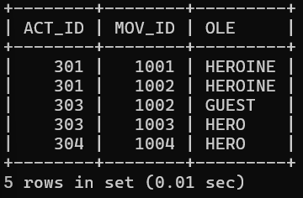

**Values of RATING**

**Code:**

INSERT INTO RATING VALUES (1001, 4);

INSERT INTO RATING VALUES (1002, 2);

INSERT INTO RATING VALUES (1003, 5);

INSERT INTO RATING VALUES (1004, 4);

**Output:**

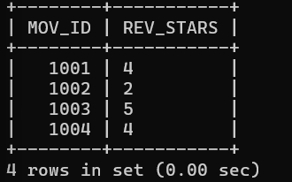

**Write SQL queries to**

**1. List the titles of all movies directed by ‘Hitchcock’.**

**Code:**

SELECT MOV_TITLE

FROM MOVIES m

JOIN DIRECTOR d ON m.DIR_ID = d.DIR_ID

WHERE d.DIR_NAME = 'HITCHCOCK';

**Output:**

**2. Find the movie names where one or more actors acted in two or more movies.**

**Code:**

SELECT DISTINCT m.MOV_TITLE

FROM MOVIES m

JOIN MOVIE_CAST mc ON m.MOV_ID = mc.MOV_ID

WHERE mc.ACT_ID IN (

SELECT ACT_ID

FROM MOVIE_CAST

GROUP BY ACT_ID

HAVING COUNT(DISTINCT MOV_ID) >= 2

);

**Output:**



**3. List all actors who acted in a movie before 2000 and also in a movie after 2015 (use JOIN operation).**

**Code:**

SELECT DISTINCT a.ACT_NAME

FROM ACTOR a

JOIN MOVIE_CAST mc1 ON a.ACT_ID = mc1.ACT_ID

JOIN MOVIES m1 ON mc1.MOV_ID = m1.MOV_ID

JOIN MOVIE_CAST mc2 ON a.ACT_ID = mc2.ACT_ID

JOIN MOVIES m2 ON mc2.MOV_ID = m2.MOV_ID

WHERE m1.MOV_YEAR < 2000 AND m2.MOV_YEAR > 2015;

**Output:**

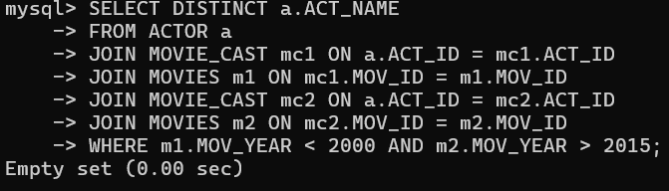

**4. Find the title of movies and number of stars for each movie that has at least one rating and find the highest number of stars that movie received. Sort the result by movie title.**

**Code:**

SELECT m.MOV_TITLE, r.REV_STARS, (

SELECT MAX(r1.REV_STARS)

FROM RATING r1

WHERE r1.MOV_ID = m.MOV_ID

) AS MAX_STARS

FROM MOVIES m

JOIN RATING r ON m.MOV_ID = r.MOV_ID

ORDER BY m.MOV_TITLE;

**Output:**

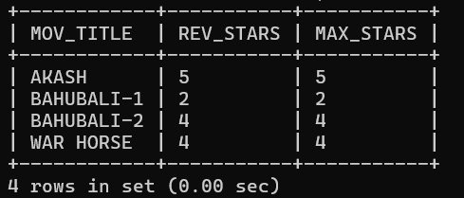

**5. Update rating of all movies directed by ‘Steven Spielberg’ to 5.**

**Code:**

UPDATE RATING

SET REV_STARS = '5'

WHERE MOV_ID IN (

SELECT m.MOV_ID

FROM MOVIES m

JOIN DIRECTOR d ON m.DIR_ID = d.DIR_ID

WHERE d.DIR_NAME = 'STEVEN SPIELBERG'

);

**Output:**

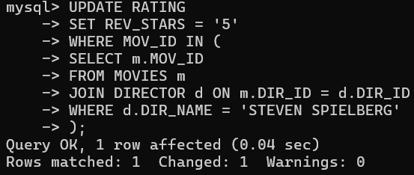

**3. Design ERD for the following schema and execute the following Queries on it:**

**Code:**

CREATE TABLE students (

stno INT PRIMARY KEY,

name VARCHAR(50),

addr VARCHAR(255),

city VARCHAR(50),

state VARCHAR(2),

zip VARCHAR(10)

);

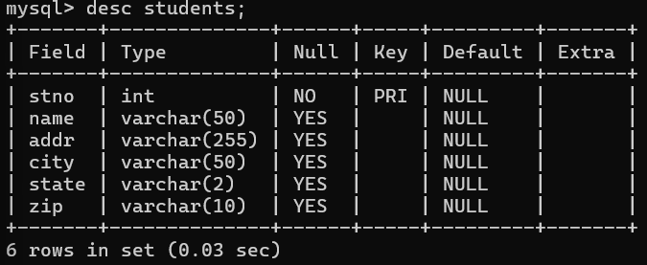

CREATE TABLE INSTRUCTORS (

empno INT PRIMARY KEY,

name VARCHAR(50),

`rank` VARCHAR(20),

roomno VARCHAR(10),

telno VARCHAR(15)

);

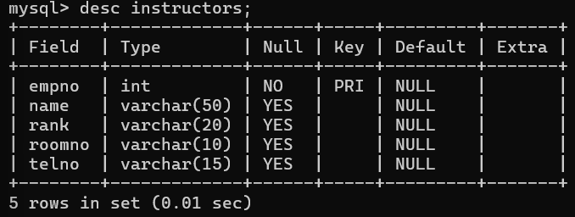

CREATE TABLE COURSES (

cno INT PRIMARY KEY,

cname VARCHAR(50),

cr INT,

cap INT

);



CREATE TABLE GRADES (

stno INT,

empno INT,

cno INT,

sem VARCHAR(10),

year INT,

grade INT,

PRIMARY KEY (stno),

FOREIGN KEY (stno) REFERENCES students(stno),

FOREIGN KEY (empno) REFERENCES INSTRUCTORS(empno),

FOREIGN KEY (cno) REFERENCES COURSES(cno)

);

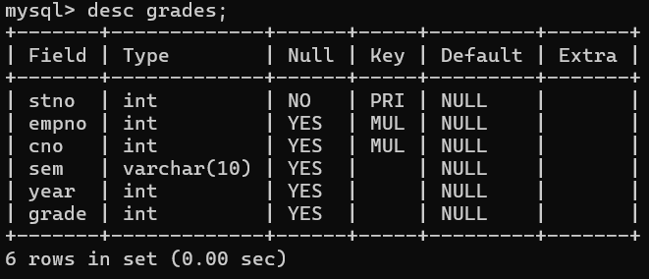

CREATE TABLE ADVISING (

stno INT,

empno INT,

PRIMARY KEY (stno, empno),

FOREIGN KEY (stno) REFERENCES students(stno),

FOREIGN KEY (empno) REFERENCES INSTRUCTORS(empno)

);

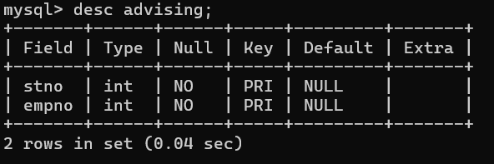

**Code:**

INSERT INTO COURSES (cno, cname, cr, cap)

VALUES

(1, 'Math101', 3, 30),

(2, 'CS210', 4, 25),

(3, 'Physics101', 3, 20);

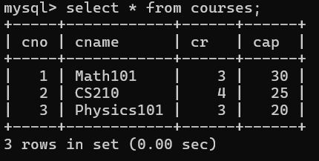

INSERT INTO students (stno, name)

VALUES

(1, 'John Doe'),

(2, 'Jane Smith'),

(3, 'Alice Johnson');

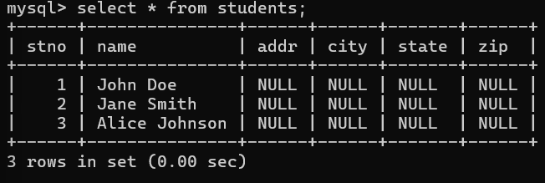

INSERT INTO instructors (empno, name)

VALUES

(101, 'Instructor A'),

(102, 'Instructor B'),

(103, 'Instructor C');

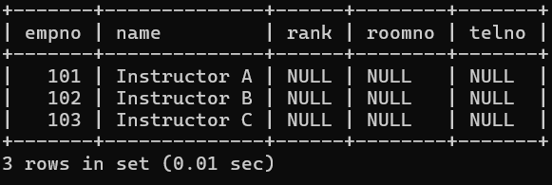

INSERT INTO GRADES (stno, empno, cno, sem, year, grade)

VALUES

(1, 101, 1, 'Fall', 2021, 85),

(2, 102, 2, 'Fall', 2021, 92),

(3, 103, 3, 'Fall', 2021, 78);

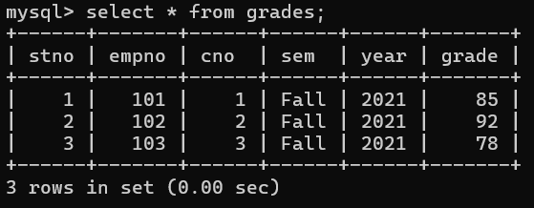

INSERT INTO ADVISING (stno, empno)

VALUES

(1, 101),

(2, 102),

(3, 103);

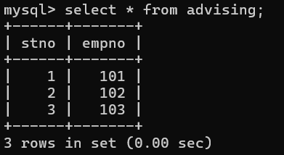

**For odd rollnumbers(any 10 )**

**1. Find the names of students who took some four-credit courses.**

**Code:**

SELECT DISTINCT s.name

FROM students s

JOIN grades g ON s.stno = g.stno

JOIN courses c ON g.cno = c.cno

WHERE c.cr = 4;

**Output:**

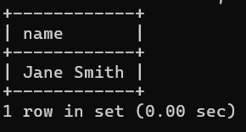

**2. Find the names of students who took every four-credit course.**

**Code:**

SELECT s.name

FROM students s

WHERE NOT EXISTS (

SELECT 1

FROM courses c

WHERE c.cr = 4 AND NOT EXISTS (

SELECT 1

FROM grades g

WHERE g.stno = s.stno AND g.cno = c.cno

)

);

**Output:**

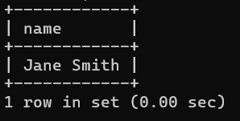

**3. Find the names of students who took a course with an instructor who is also their advisor.**

**Code:**

SELECT DISTINCT s.name

FROM students s

JOIN grades g ON s.stno = g.stno

JOIN instructors i ON g.empno = i.empno

JOIN advising a ON s.stno = a.stno

WHERE g.empno = a.empno;

**Output:**

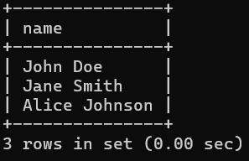

**4. Find the names of students who took cs210 and cs310.**

**Code:**

SELECT s.name

FROM students s

WHERE EXISTS (

SELECT 1

FROM grades g

JOIN courses c ON g.cno = c.cno

WHERE s.stno = g.stno AND c.cname = 'cs210'

)

AND EXISTS (

SELECT 1

FROM grades g

JOIN courses c ON g.cno = c.cno

WHERE s.stno = g.stno AND c.cname = 'cs310'

);

**Output:**

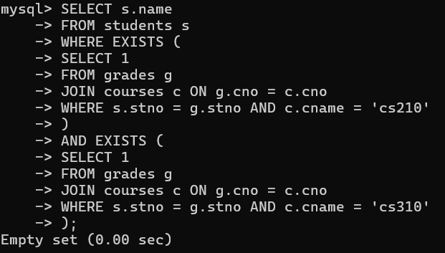

**5. Find the names of all students whose advisor is not a full professor.**

**Code:**

SELECT DISTINCT s.name

FROM students s

JOIN advising a ON s.stno = a.stno

JOIN instructors i ON a.empno = i.empno

WHERE i.rank <> 'Full Professor';

**Output:**

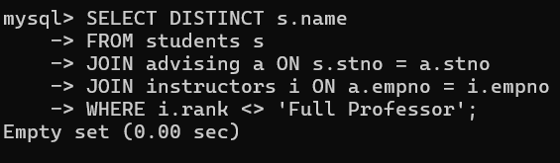

**6. Find instructors who taught students who are advised by another instructor who shares the same room.**

**Code:**

SELECT DISTINCT i1.name

FROM instructors i1

JOIN grades g ON i1.empno = g.empno

JOIN advising a ON g.stno = a.stno

JOIN instructors i2 ON a.empno = i2.empno

WHERE i1.roomno = i2.roomno AND i1.empno <> i2.empno;

**Output:**

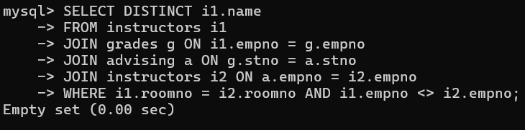

**7. Find course numbers for courses that enroll exactly two students**

**Code:**

SELECT g.cno

FROM grades g

GROUP BY g.cno

HAVING COUNT(DISTINCT g.stno) = 2;

**Output:**

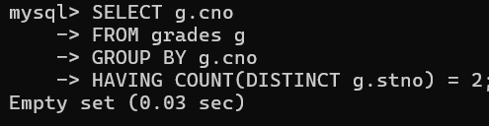

**8. Find the names of all students for whom no other student lives in the same city.**

**Code:**

SELECT s1.name

FROM students s1

WHERE NOT EXISTS (

SELECT 1

FROM students s2

WHERE s1.city = s2.city AND s1.stno <> s2.stno

);

**Output:**

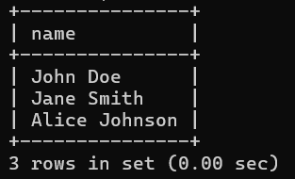

**9. Find course numbers of courses taken by students who live in Boston and which are taught by an associate professor.**

**Code:**

SELECT DISTINCT g.cno

FROM grades g

JOIN students s ON g.stno = s.stno

JOIN instructors i ON g.empno = i.empno

WHERE s.city = 'Boston' AND i.rank = 'Associate Professor';

**Output:**

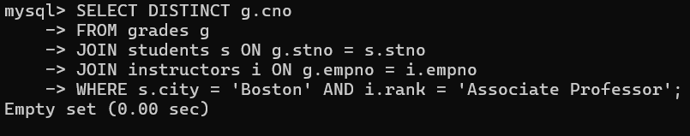

**10. Find the telephone numbers of instructors who teach a course taken by any student who lives in Boston.**

**Code:**

SELECT DISTINCT i.telno

FROM instructors i

JOIN grades g ON i.empno = g.empno

JOIN students s ON g.stno = s.stno

WHERE s.city = 'Boston';

**Output:**

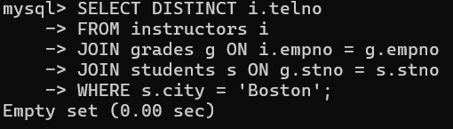

**11. Find names of students who took every course taken by Richard Pierce.**

**Code:**

SELECT s.name

FROM students s

WHERE NOT EXISTS (

SELECT 1

FROM grades g1

JOIN students rp ON rp.name = 'Richard Pierce'

JOIN grades g2 ON rp.stno = g2.stno

WHERE g1.cno = g2.cno AND g1.stno <> s.stno

);

**Output:**

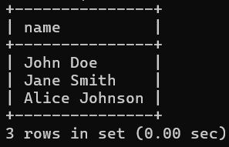

**12. Find the names of students who took only one course.**

**Code:**

SELECT s.name

FROM students s

JOIN grades g ON s.stno = g.stno

GROUP BY s.stno, s.name

HAVING COUNT(DISTINCT g.cno) = 1;

**Output**

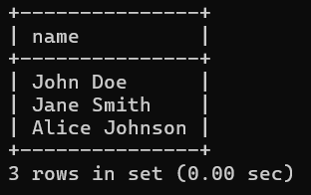

**13. Find the names of instructors who teach no course.**

**Code:**

SELECT i.name

FROM instructors i

LEFT JOIN grades g ON i.empno = g.empno

WHERE g.cno IS NULL;

**Output:**

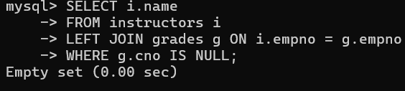

**14. Find the names of the instructors who taught only one course during the spring semester of 2001.**

**Code:**

SELECT i.name

FROM instructors i

JOIN grades g ON i.empno = g.empno

WHERE g.sem = 'Spring' AND g.year = 2001

GROUP BY i.empno, i.name

HAVING COUNT(DISTINCT g.cno) = 1;

**Output:**

